# Overview

In this guided practice, you will install Active Directory on the first domain controller in an Active Directory Forest. You will then join the remaining computers and servers to the domain. Finally, you will add the **Server-02** virtual machine as an additional domain controller in the domain.

# Objectives

* Implement an Active Directory infrastructure to support the needs of a typical business environment.
  + Install Active Directory

## Skills Reviewed

* Installing server roles in Windows Server.
* Joining computers and servers to a domain.

## New Skills

* Installing Active Directory in a New Forest.
* Adding a domain controller to an existing domain.

## References

# Initial conditions

Guided Practice – Advanced DNS Configuration is complete

# Final Conditions

* The active directory domain **kmw.local** is created
* A personal user account for the student is created in AD.
* The **KMWAdmin** account is created and configured.
* All systems are joined to the **kmw.local** domain.
* The **Server-02** computer is added as an additional domain controller in the **kmw.local** domain.

# Instructions

## Establishing Prerequisites for Installing Active Directory

To install Active Directory, your server must meet the following prerequisites:

* Running Windows Server operating system.
* Have a static IP address.
* Operating system partition must use the NTFS file system.
* Have AD Domain Services role installed.

The only prerequisite that has not been met is the AD-Domain-Services role. To establish prerequisites for installing Active Directory, perform the following:

1. Login to **Server-01**
2. Install the **Active Directory Domain Services** role.

## Creating the forest root domain

1. Open **Server Manager**
2. Startthe **Active Directory Domain Services Installation Wizard,** by selecting the link in the **Notifications** menu in **Server Manager**.
3. 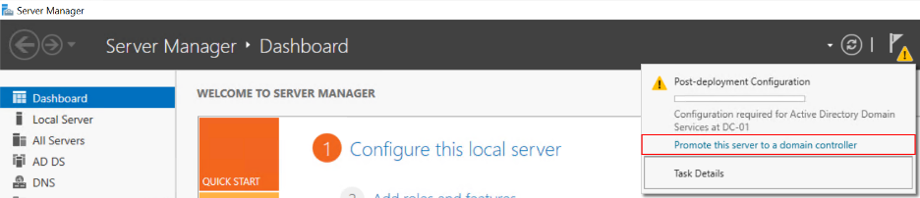On the **Deployment Configuration** page of the wizard, select **Add a new forest** radio button and **type kmw.local** in the **Root domain** name text box. **Click** the **Next** button.
4. On the **Domain Controller options** page of the wizard, verify the **Forest** and **Domain** **functional** **levels** are **Windows Server 2016,** the **Domain Name System (DNS) server** **checkbox** is **selected**, and type **Password1** in the **Password** and **Confirm password** text boxes as shown in the figure below. Click the **Next** button.
5. 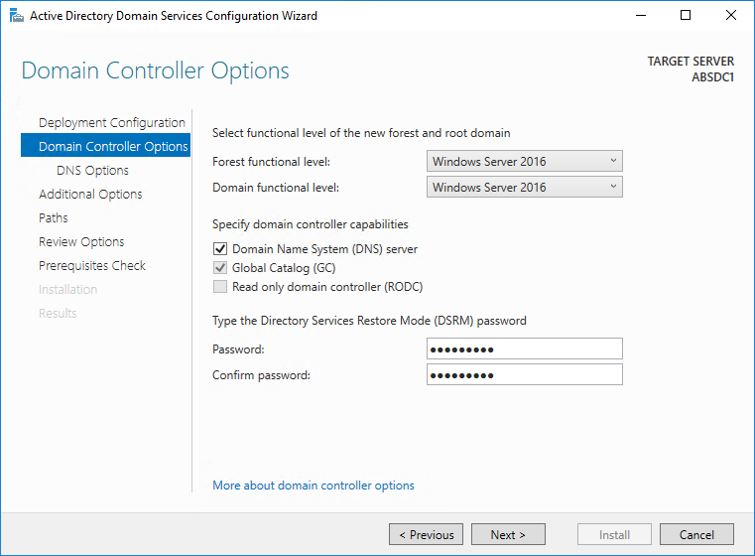On the **DNS Options** page of the wizard, you will get a message about not being able to create a DNS delegation. Read the message and click the **Next** button.
6. On the **Additional Options** page of the wizard, verify that **KMW** is listed in the **NetBIOS domain name**: textbox and click the **Next** button.
7. On the **Paths** page of the wizard, note the **location** of the Database, Log Files, and SYSVOL folder and click the **Next** button.
8. On the **Review Options** page of the wizard, review the settings and click the **View** **script** button. **Save** the text file on your desktop as **Install**-**Forest**.**ps1**. Close the file and click the **Next** button.
9. On the **Prerequisites** **Check** page of the wizard **read** the **warnings** and **click** the **Install** button.
10. Reboot your system when done.

## Verify the installation of Active Directory

Logon to your system as the administrator and verify that Active Directory was properly installed by verifying the following:

1. Active Directory Tools were installed.
   1. AD Users and Computers.
   2. AD Sites and Services.
2. The **Sysvol** share was created.
3. The Active Directory database is in the proper location.
4. DNS has the required service locator records.
5. Review the logs in the Event Viewer and address any errors.
6. Run the **dcdiag** command and resolve any relevant errors.

## Additional Configurations

### Creating a personal account and an administrative account

Create the following accounts in Active Directory:

1. Create an unprivileged user **account** using your **first initial + lastname** (e.g. kazevedo). Set the password to **Password1**.
2. Create a user account named **KMWAdmin**. Set the password to **Password1**.
3. Add **KMWAdmin** to the **Domain Admins** and **Enterprise Admins** groups

When performing labs, you should logon to your computer using your personal account and use the **KMWAdmin** account when prompted to perform administrative tasks.

### Join the remaining virtual machines to the domain

1. Join the **remaining** virtual machines to the **kmw.local** domain. You may join **Client-01** and **Client-02** manually or using PowerShell.
2. To join **Server-02** to the domain, on **Server-02** issue PowerShell command

Add-Computer -DomainName kmw.local -DomainCredential kmw\administrator -Restart

## Adding an Additional Domain Controller to a Domain

It is recommended that there are at least two domain controllers for a given domain and at least one domain controller for every physical location. This allows for the failure of one domain controller and for the failure of a WAN connection.

To add an additional domain controller to the **kmw.local** domain, perform the following:

1. Login to the **Server-02** virtual machine using the **kmwadmin** account.
2. Opena **PowerShell** session.
3. Establish the prerequisites for **Active Directory** installation.
4. Install **Active Directory** as an **additional domain controller** in the **kmw.local** domain. Using the following commands:

Install-WindowsFeature -Name Ad-Domain-Services -IncludeManagementTools

Install-ADDSDomainController -DomainName kmw.local -SkipPreChecks -SafeModeAdministratorPassword (ConvertTo-SecureString Password1 -AsPlainText -Force) -Force

1. VerifyActive Directory installation. Minimally, check **Active Directory Users and Computers** on **DC-01**. Computer **DC-02** should appear in the Domain Controllers folder after a refresh.

# Submission Requirements

1. **Download** the **grading** **script** from the assignment page to the **C:\Scripts** folder.
2. Check your lab by running the following command:

Invoke-Pester -Path C:\Scripts\GP12-Installing_Active_ Directory.test.ps1

**Note**: You will see a security warning when running the script. Enter **R** to run the script.

If you want to see more detail, add **-Output Detailed** to the command. This may assist you with troubleshooting

Invoke-Pester -Path C:\Scripts\GP12-Installing_Active_ Directory.test.ps1 -Output Detailed

1. You should not see any red in the output. Red in the PowerShell way of telling you that an error condition exists. Most of the time, the output will tell you what is wrong. If it is not obvious, contact your teacher and ask for assistance. You will be learning PowerShell during this term. **Correct** any **errors** you may have and run the script until all the output has no red. You should see the output like the images below

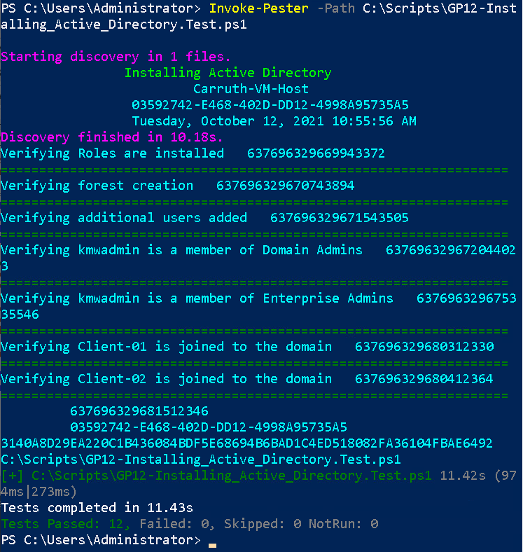

1. Capture a snippet that shows the PowerShell Command and all its output. If you must use more than one snippet to capture the output, you must have at least **one line of overlap** in the snippets. The text in the snippets **must be legible** when pasted into the Word document. Paste the snippet(s) into a **new** **Word** **document**
2. **Fill** **in** the **information** in the following table. Copy the following table into the **Word** **document** and fill in the information about all the **new** commands used in this lab (the example provided is not a new command and should be deleted):

|  |  |  |
| --- | --- | --- |
| PowerShell Commands | | |
| Command | Example | Description |
| *Get-Childitem* | *Get-Childitem -Path C:* | *Displays the files in the C:\ directory* |
|  |  |  |
|  |  |  |
|  |  |  |
|  |  |  |
|  |  |  |

1. **Upload** the **document** in the submission area of the assignment.